Smart Farm System

Samuel I. Gunadi

# Project Website

https://github.com/multiprecision/smart_farm_arduino

# Value Proposition

*Monitor your farm anytime, anywhere.*

The Smart Farm System allows real-time monitoring of air temperature, air humidity, light intensity, and soil moisture on their farm. Users can monitor their farm from the web and mobile application via *thinger.io* IoT platform. The system gives users notification via LCD screen and web application if the soil is too dry. Project website: https://github.com/multiprecision/smart_farm_arduino

# Conceptual Model

Prototyping board Arduino Yun is used. Arduino Yun has onboard Wi-Fi and Ethernet so it can directly connect to the Internet and send data to server.

There are 3 sensors used:

1. Temperature and humidity sensor.

|  |  |
| --- | --- |
| Model | DHT22 |
| Description | The DHT22 is a basic, low-cost digital temperature and humidity sensor. It uses a capacitive humidity sensor and a thermistor to measure the surrounding air. |
| Output | Digital |

1. Luminosity Sensor

|  |  |
| --- | --- |
| Model | TSL2561 |
| Description | The TSL2561 luminosity sensor is an advanced digital light sensor, ideal for use in a wide range of light situations. Compared to low cost CdS cells, this sensor is more precise, allowing for exact lux calculations and can be configured for different gain/timing ranges to detect light ranges from up to 0.1 - 40,000+ Lux on the fly. It contains both infrared and full spectrum diodes. |
| Output | Digital (I2C) |

1. Soil moisture sensor.

|  |  |
| --- | --- |
| Model | RobotDyn |
| Description | The soil moisture sensor is used for measuring the volumetric content of water in the soil. |
| Output | Analog |

Plus, there’s a 20×4 characters LCD screen with an I2C backpack to display data from the sensors[1] and a button to toggle data transmission.

The IoT platform *thinger.io* is used to store data and display data via web application and mobile application. The devices send data in binary JSON format (thinger.io internal protocol called protoson) to thinger.io servers. Data from the sensors is pulled every 2 seconds, i.e., the polling interval is 2 seconds, and then the data is sent to thinger.io server.

The schematics is shown below.

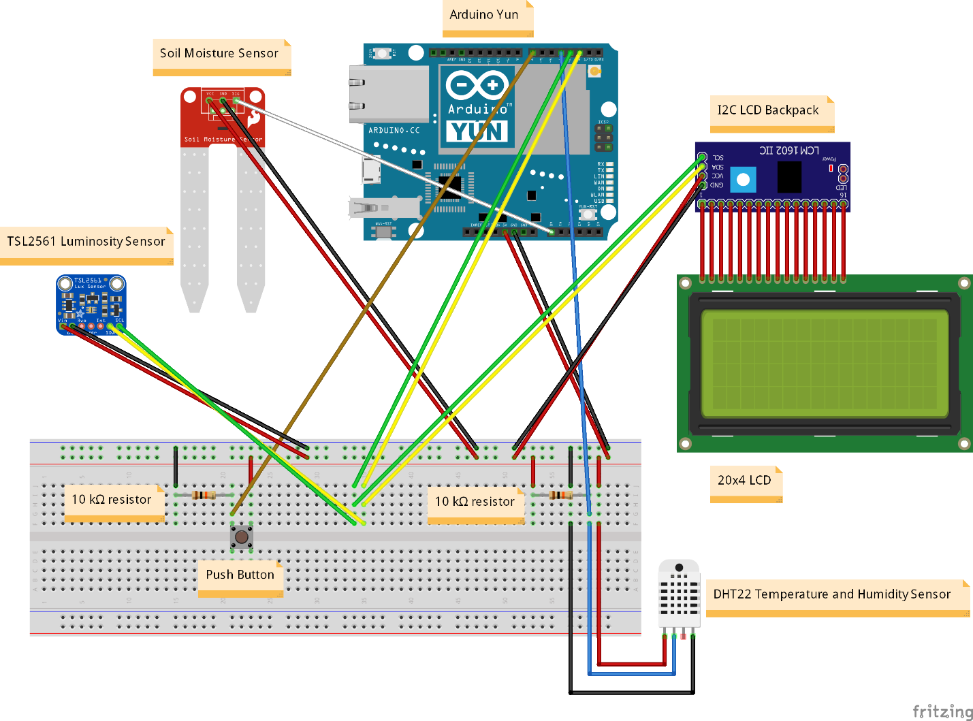

The prototype hardware is shown on below.

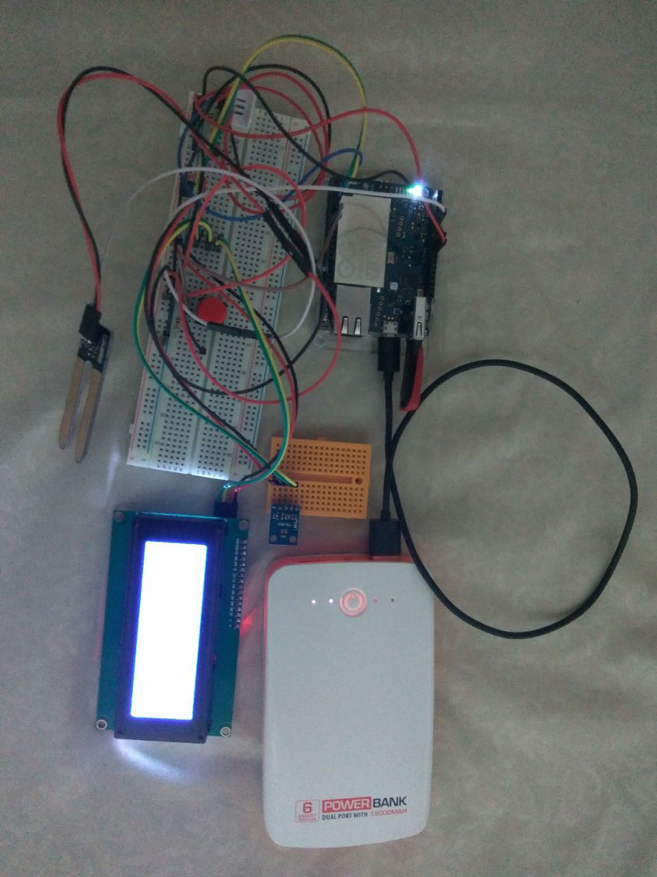

# Interaction Model

The IoT platform thinger.io dashboard can be accessed from any device with a web browser, so desktops, laptops, and smartphones can access the dashboard. Users interact through the dashboard and can monitor their farms from here or set the threshold for when the soil is too dry. The local rule for the soil moisture too dry threshold is 25%. Users can modify this threshold via the dashboard (cloud rule).

1. The web dashboard

Monitor:

* Current air temperature, air humidity, soil moisture, and light intensity.
* Average, minimum, and maximum air temperature, air humidity, soil moisture, and light intensity in 1 day, 1 month, or 1 year.

Set:

* Soil moisture threshold for notification.
* Data transmission toggle (disable/enable).

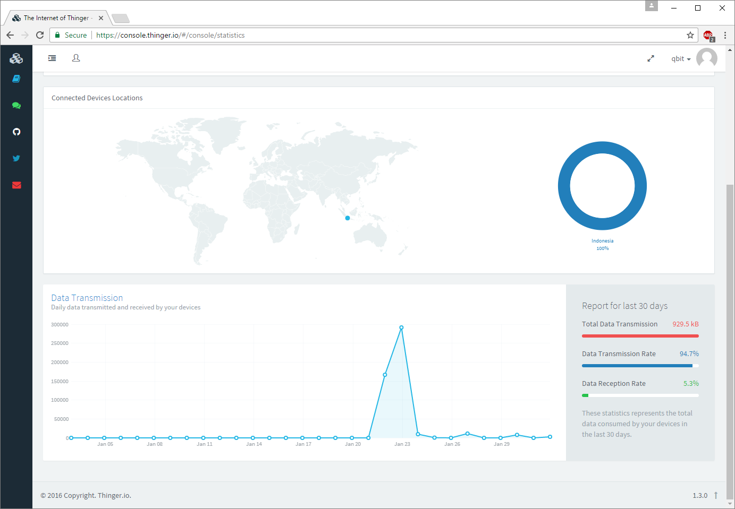

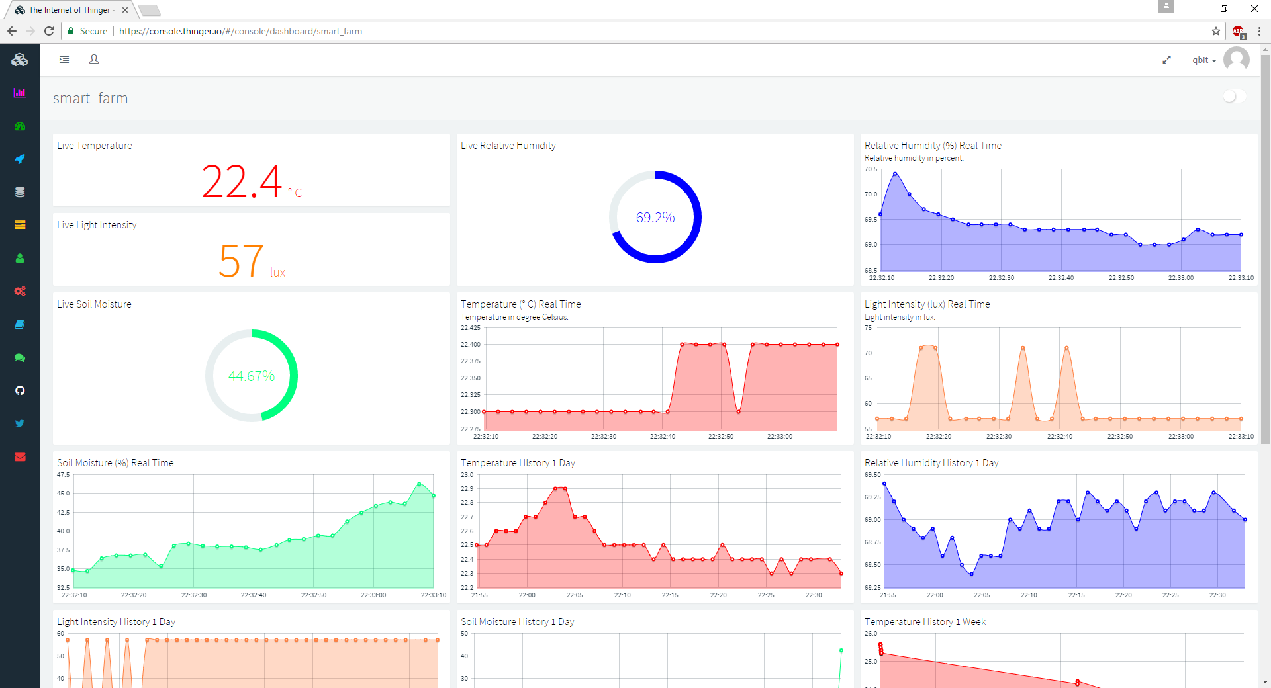

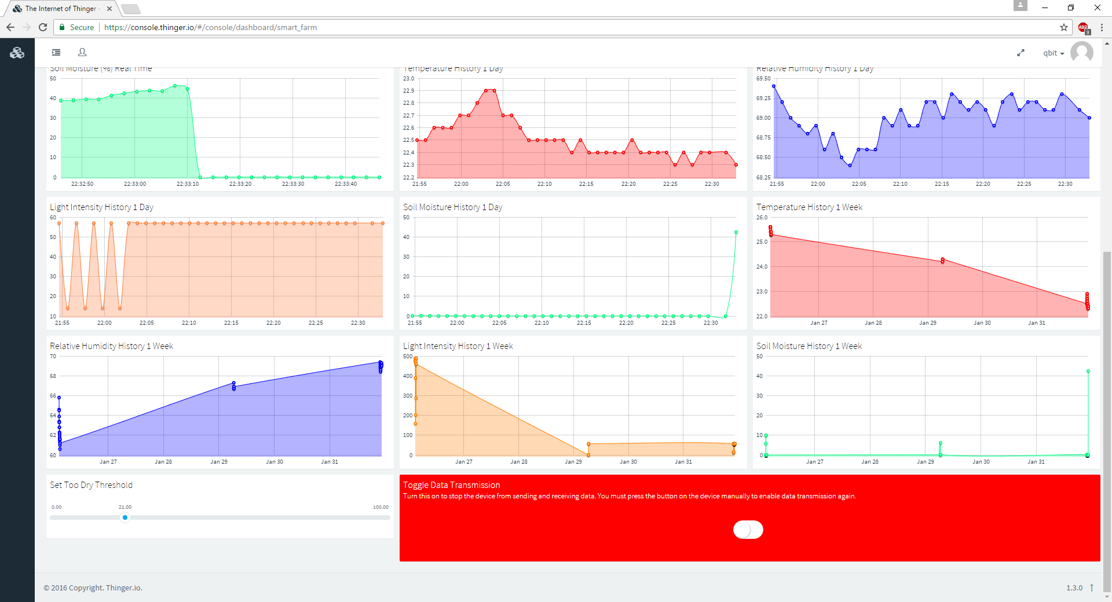

1. The hardware
   1. The LCD

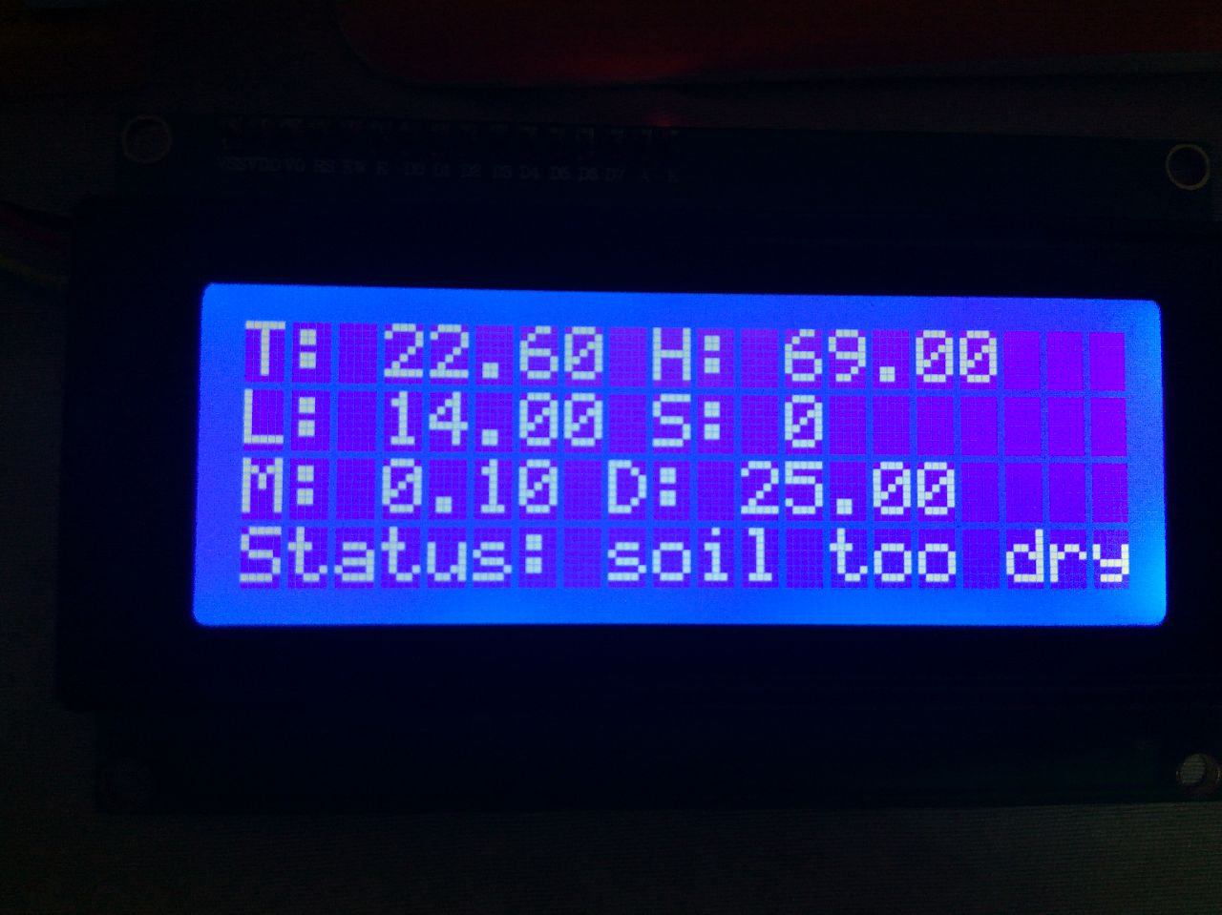

Legends

|  |  |
| --- | --- |
| T | Temperature in degree Celcius. |
| H | Relative humidity in percent. |
| L | Light intensity in lux. |
| M | Soil moisture in percent. |
| D | Soil moisture too dry threshold in percent. An asterisk (*) will be shown next to the number if this value is modified from the online dashboard (cloud rule). |
| S | Data transmission toggle. 1 means the device won’t transmit/receive data. 0 means the device will transmit/receive data. An asterisk (*) will be shown next to the number if this value is modified from the online dashboard (cloud rule). Pressing the button on the device will hide the asterisk. |
| Status | The current status of the soil. |

* 1. The button

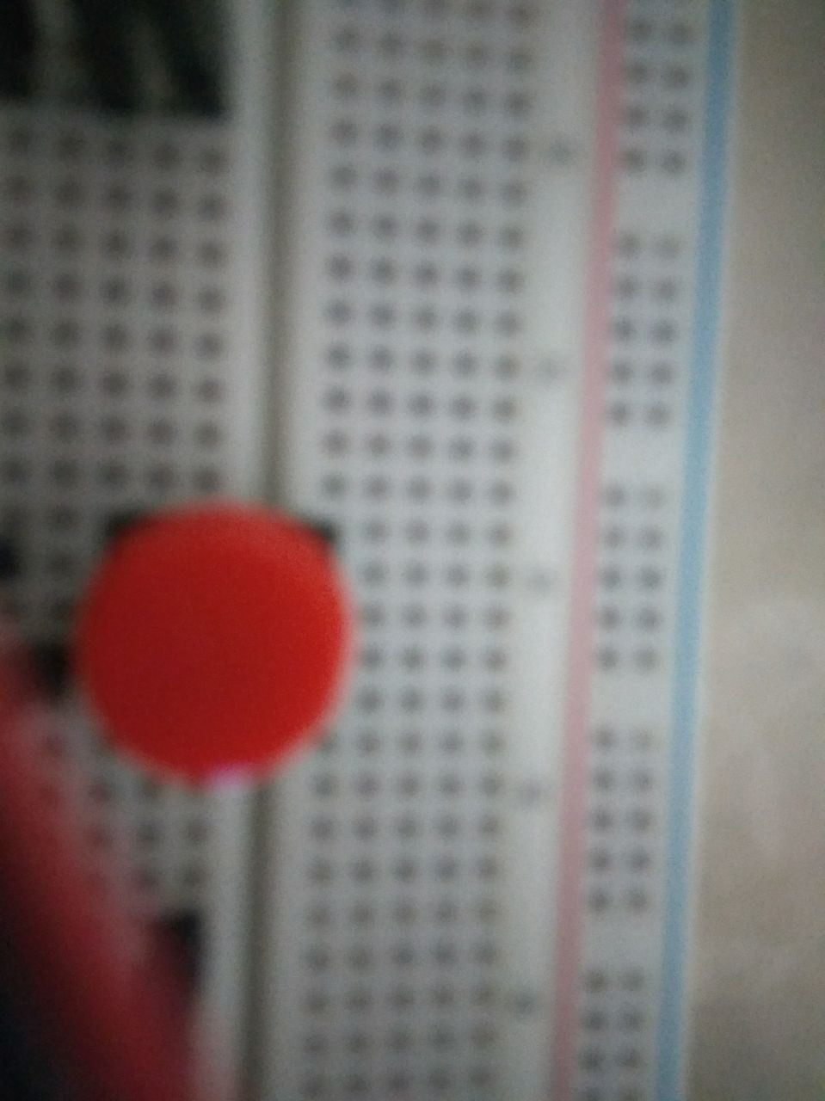

Push this button to toggle data transmission, e.g., when you need to save bandwidth or when online monitoring isn’t needed (monitoring from the LCD is enough).

1. An LED for when the soil is to dry is deemed redundant here.